### **Covid-19 Blog Post**

Group D

**I. Research Question**

Our research question is:

**“Trust in government and its economic implication under pandemic**

**—— How trust in the government affects the spread of the COVID-19 epidemic and its economic impact.”**

The world is experiencing this unprecedented tragedy pandemic together right now. Despite economic and medical conditions, we all have one goal --- to keep everyone safe and healthy. Among all countries and regions, there are variations of results and influences of the impact of the virus. We think it would be an interesting and inevitable topic to analyze how trust in government affects public compliance with preventive precaution during COVID-19 and as a result, impact the economy in all sorts of ways.

To better specify our research, we want to set up two observation groups for comparison. We would collect data from two developing countries in Asia and two developed countries in Europe to conduct our research.

We cut the timeline to six month as a constraint. Ideally, we would collect and analyze data from March 1st to September 1st 2020. The spread of COVID-19 can be traced back to late 2019 in some areas (ex: Hubei province, China) and gradually infected the world. We picked this six-month duration to better cope with the situation.

**II. Hypotheses**

* Data source:World Bank,
* X: The level of public’s trust in government

Y: The control over the spread of COVID-19

Z: Economic impact (ex: tourism)

A1: Government’s policies & responsiveness & risk communication

ex：Real-time monitoring system (case tracker)

A2: Cultural differences among the world

ex: Attitude toward precaution measures (wearing masks)

* Alpha group: Asian (China, ?)

Beta group: Europe (！！！, ?)

* Time range: 2020.3 - 2020. 9 (six months)

**II. Background Statistics**

1. Current situation

Globally, as of 3 October, there have been 34,495,176 confirmed cases of COVID-19, including 1,025,729 deaths, reported to WHO.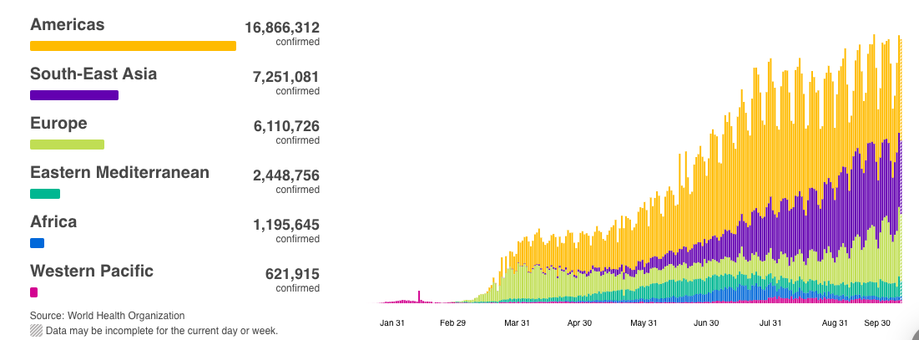

*Chart on confirmed COVID cases worldwide

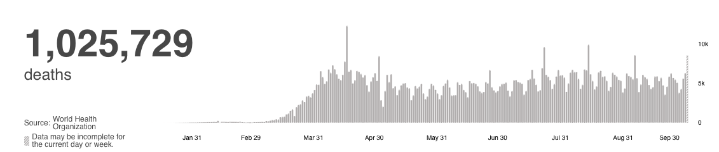

*Chart on COVID deaths

1. Trust in government among different regions

People’s trust during this COVID-19 is imperative as it determines their adherence to public health policy, procedures, and restrictions. Communication by the government is key to combating Covid-19 and preventing the spread of the disease. Governments around the world have responded to Covid-19 by implementing different measures such as social distancing, wearing of masks, quarantine, contact tracing, and the safe burial of persons who die because of Covid-19.

Newton believes that compliance with the challenging behavior needed to prevent the spread of Covid-19 depends on the citizens' confidence and trust in their government. A survey done by Gallup showed that 81% of people in the United Kingdom in 2018 trusted the medical and health information given by the government compared to 83% in Germany and 63% in Italy (Newton, 2020). The difference between government communication on the Covid-19 pandemic and the media causes public anxiety and the spread of the disease.

1. Economic implications

The COVID-19 epidemic has caused a significant impact on the world economy.The COVID-19 pandemic has resulted in more than 4.3 million confirmed cases and more than 290,000 deaths worldwide. It also raised concerns about the coming economic crisis and recession. Social distancing, self-isolation, and travel restrictions have led to a reduction in the labor force in all economic sectors and led to the loss of many jobs. Schools have been closed, and demand for commodities and manufactured goods has decreased.

The impact of the epidemic on the macro economy: The spread of panic has led to a setback in investor confidence, which has caused turmoil in the financial and capital markets;The new crown has also had a great impact on the education industry of various countries. Various countries have implemented various policies, from the complete closure of Germany and Italy to the targeted closure of the United Kingdom. In addition, courses in many countries have also been changed to online courses. In the new semester, there are also a large number of students who choose to postpone their admissions or consider not studying abroad. UNESCO estimates that nearly 900 million learners have been affected by the closure of educational institutions.

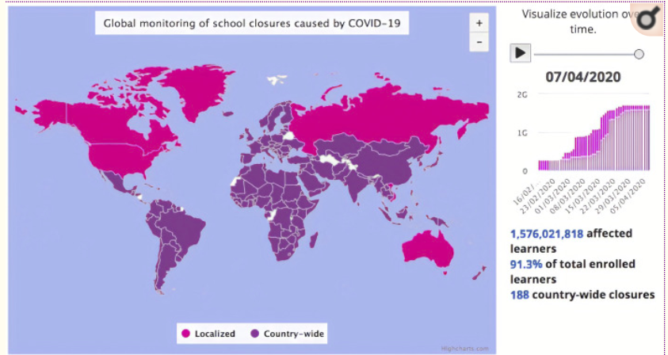

Due to the outbreak of the COVID-19 epidemic, many countries have imposed travel bans, which is a big blow to the tourism industry. From airlines to cruise companies, from casinos to hotels, the entire industry is facing a reduction in activities of more than 90%.

The graph below shows the contribution of total travel and tourism to GDP in different countries. Some countries like Greece, Portugal and Mexico will have difficult situations during the period of COVID-19 epidemic.

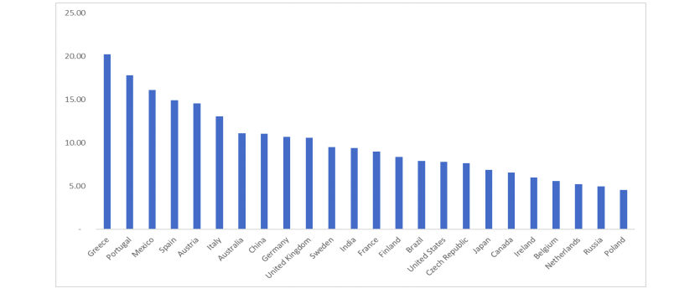

**III. Country of Interest**

Facing the grim situation of the rapid spread of overseas epidemics, many countries have been actively taking prevention and control measures. Internally, restricting or prohibiting group activities to reduce the risk of crowd gathering; externally, implementing border control and adopting strict travel restrictions.

However, the effects of such government intervention have been very different among the world. So far, Asia’s control of COVID-19 seems to be more effective and efficient than European countries. Therefore, we further analyzed the situation from the following perspectives:

1. Trust in government

Compared with European countries, the advantages of the Asian system has proven to be very effective in fighting the epidemic.

Given the cultural (Confucianism) and historical background of Asian countries (ex: Japan, South Korea, Mainland China), Asian people tend to be more obedient, and trust their government more than European countries.

1. Unconstrained data exchange

Data exchange between mobile and network providers and government agencies makes it possible to effectively manage society in China.

In the fight against the virus, big data is obviously more effective than the current meaningless border closure measures in Europe. However, due to data protection, it is impossible for Europe to take similar actions. China's mobile and Internet providers will share sensitive customer data with health management departments.

1. Cultural difference

Almost no one in Germany wears a mask, and some of them are Asians. Koreans in Germany complained that it would look strange if they wear masks. Here obviously another cultural difference is at work. The individualism that prevails in Germany is associated with naked faces.

**IV. Literature Summary**

Here are some short summaries of the literature review we have done so far.

Balog-Way, D. H., & McComas, K. A. have found that trust is critically important during such a rapidly evolving event characterized by scientific uncertainty.

Blair, Morse, and Tsal ; Vinck et al. have found that trust can influence perceived severity and transmissibility, willingness to adopt interventions such as physical distancing, and information seeking behavior.

Baruch Fischhoff found that trust building activities can enable organizations to get out in front and stay ahead of problems.

**References**

WHO Coronavirus Disease (COVID-19) Dashboard https://covid19.who.int/table

Balog-Way, D. H., & McComas, K. A. (2020). COVID-19: Reflections on trust, tradeoffs, and preparedness. Journal of Risk Research, 1-11.

Balog-Way, D. H. P., D. Evensen, R. E. Löfstedt, and F. Bouder. 2020. Effects of public trust on behavioural intentions in the pharmaceutical sector: data from six European countries. Journal of Risk Research, 1–28 doi: 10.1080/13669877.2019.1694962

Blair, R. A., B. S. Morse, and L. L. Tsai. 2017. “Public Health and Public Trust: Survey Evidence from the Ebola Virus Disease Epidemic in Liberia.” Social Science & Medicine 172: 89–97. doi:10.1016/j.socscimed.2016.11.016.

Cavallo, J. J., & Forman, H. P. (2020). The economic impact of the COVID-19 pandemic on radiology practices. Radiology, 201495.

McKibbin, W. J., & Fernando, R. (2020). The global macroeconomic impacts of COVID-19: Seven scenarios.

**CED6910 - Research Paper**

**选题大纲**

Government trust 对econ的影响

**\*关键词：**

COVID-19, trust in government, economic implication / impact on economic development (economy), from early to mid-2020, developing countries vs. developed countries

**Reasearch Question:**

大标题 + 小标题解释细节

Trust in government and its economic implication under pandemic

* The (world’s?) economic implication of COVID-19 from early to mid-2020
* How trust in government affects the public response and economy during COVID-19
* Relationships among government intervention, public compliance and economic reaction??? 啊脑壳疼

**内容提要：**

两个对照组

发达国家（欧洲？） vs. 发展中国家（东南亚？）

(发展程度相当；国情相似；地理位置/环境大致相符)

时间线

2020三月到九月 半年期限

Trust in government - 第一部分

国民对政府的信任统计 - 图

（不同国家的差别？疫情前后的变化？）

Early Stage 疫情控制 - 第二部分

case number, death number

health system的反应

precaultion supply （口罩，手套，防护服，洗手液，消毒水...）

医院的efficiency (医疗器械的提供、医护人员）

各方media的反应

newspaper vs. social media?

Twitter, Ins, Facebook...

对经济影响 - 第三部分

选一方面深入 - 哪方面数据较多？方便对比？

Supply Chain

Interstate / Intercountry Commerce / E-commerce

Transportation (Ground/Air/Water)

Travel / Tourisim

Hotel

Restaurant (Food & Beverage)

Stock market

Real estate / assets